Chapter 5, Problem 5.

For the op amp circuit of Fig. 5.44, the op amp has an open-loop gain of 100,000, an input resistance of 10 kΩ, and an output resistance of 100 Ω. Find the voltage gain v_{o}/v_{i} using the nonideal model of the op amp.

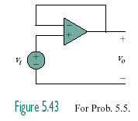

Figure 5.44
For Prob. 5.5.

